**Metasploit Framework**

1. Accessing Metasploit framework :

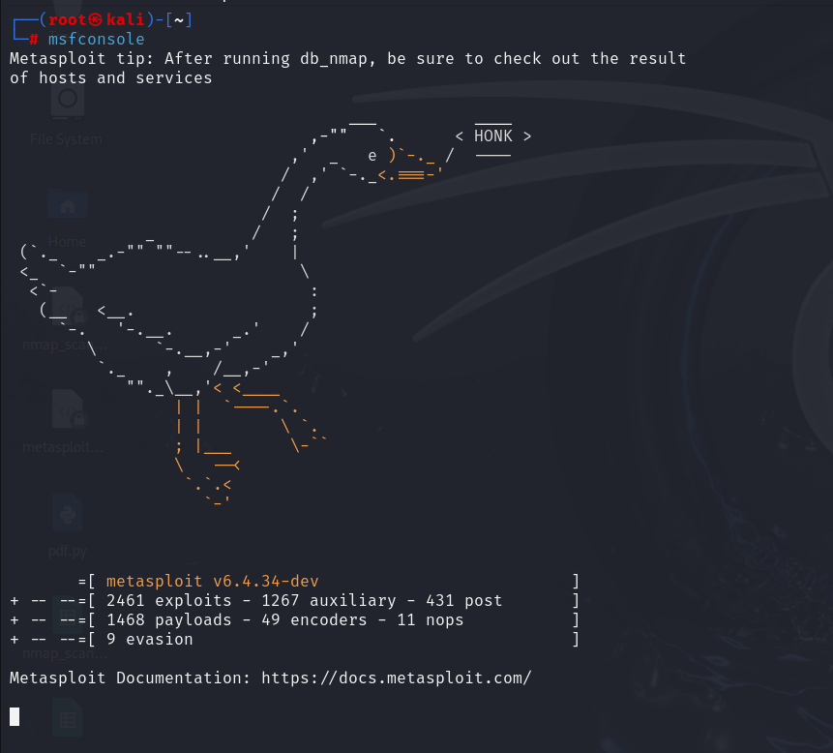

2. Exploiting vsftpd vulnerable:

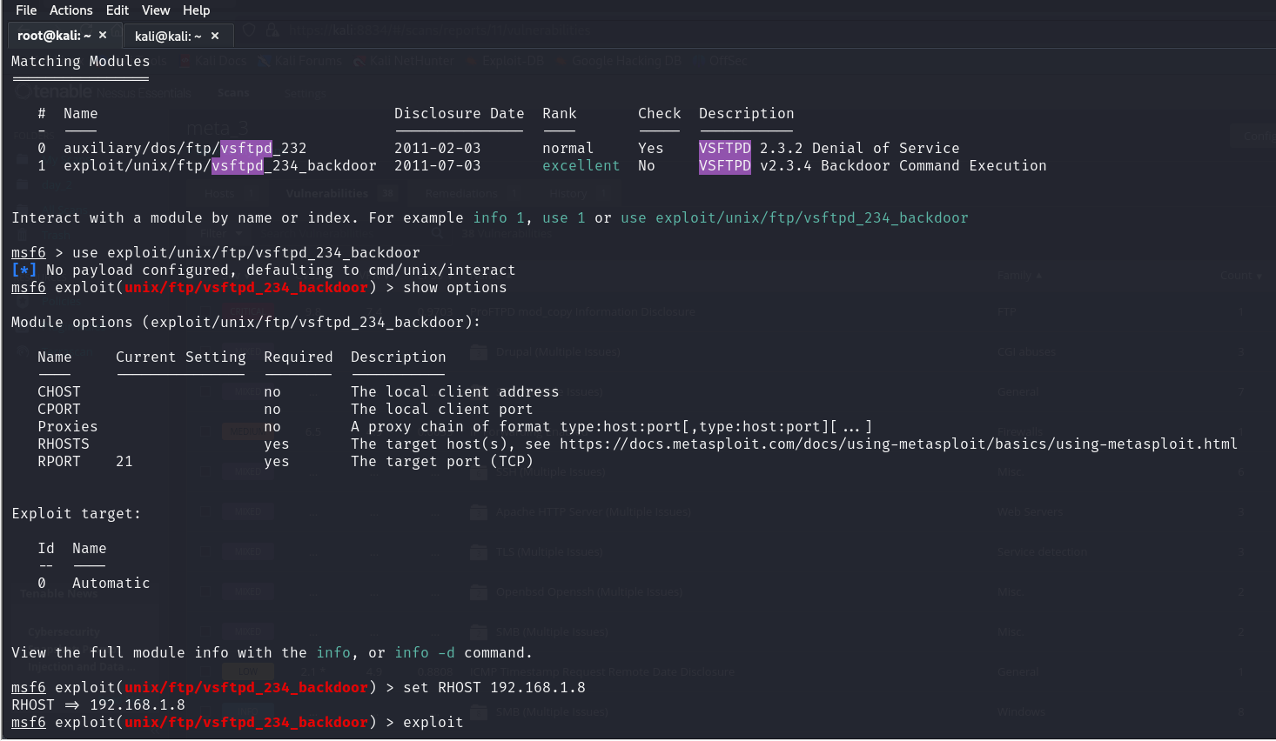

Vsftpd_234_backdoor payload configuration

3. Exploiting Apache Tomcat vulnerable:

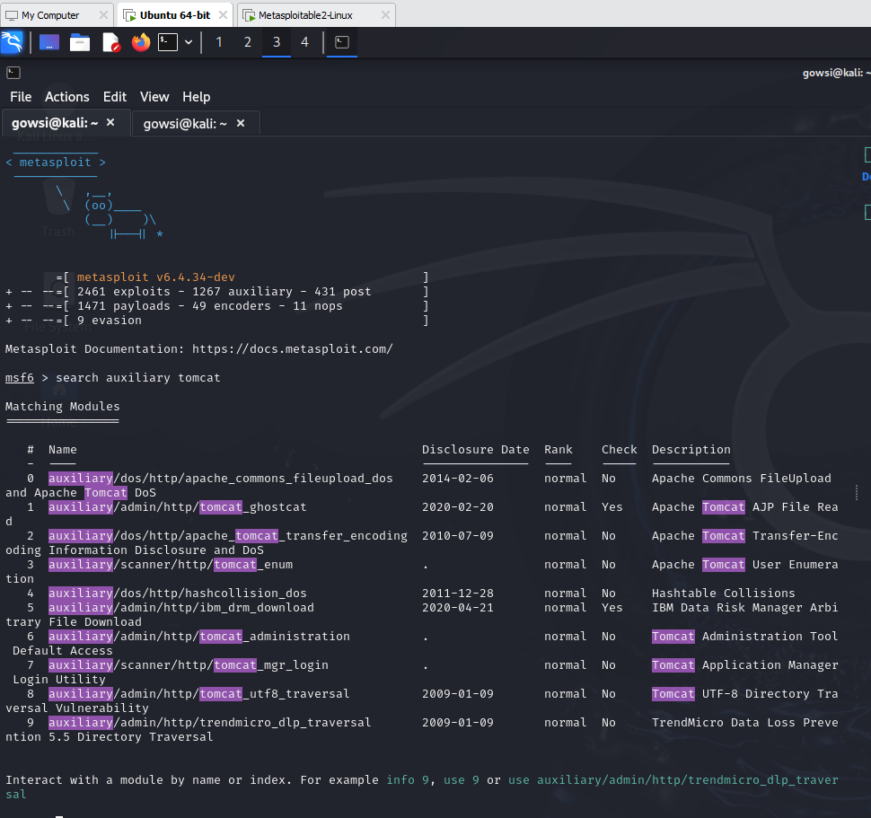

Tomcat login payload through http

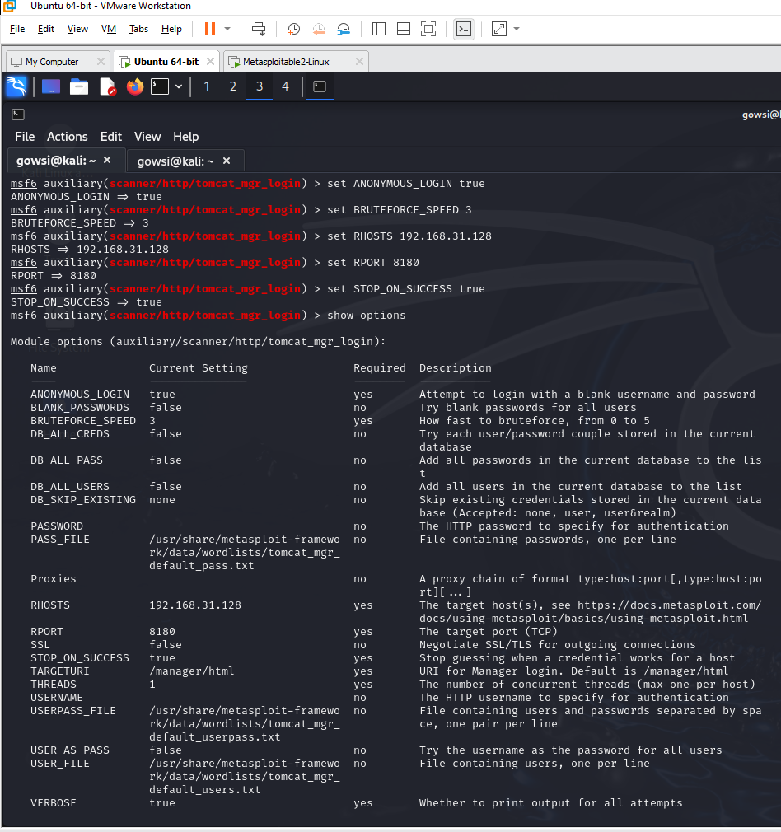

Payload configuration

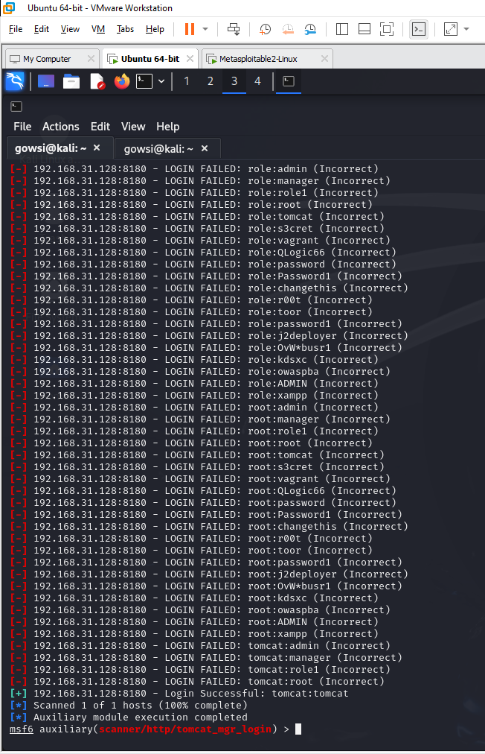

Brute-forcing to get the username and password for tomcat login

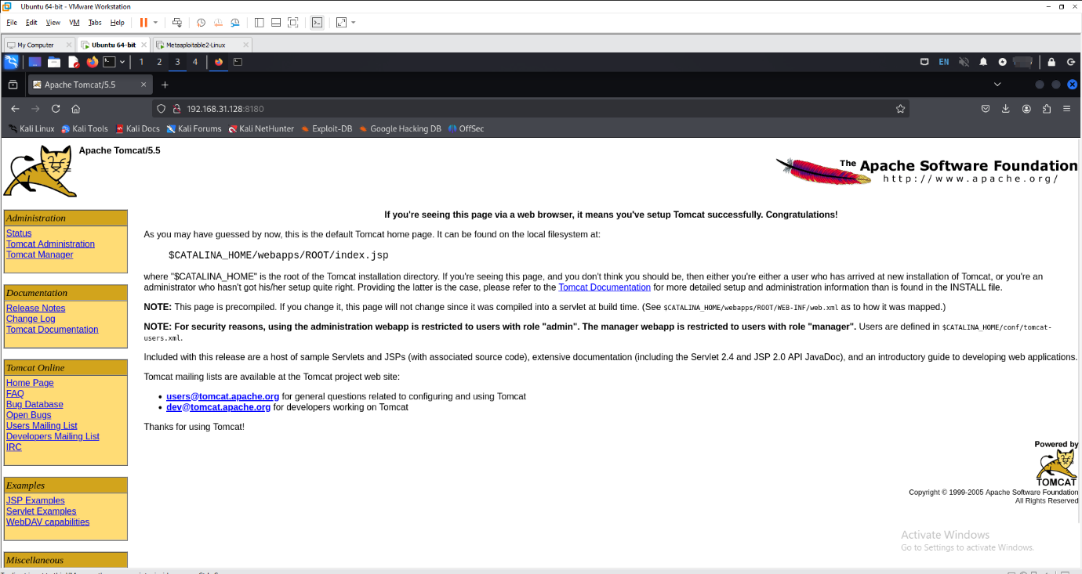

Tomcat portal page

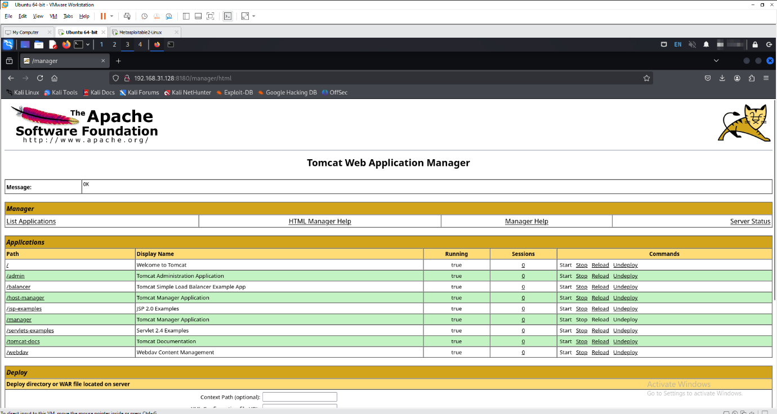

Tomcat admin page

3. Exploiting Openssh vulnerable:

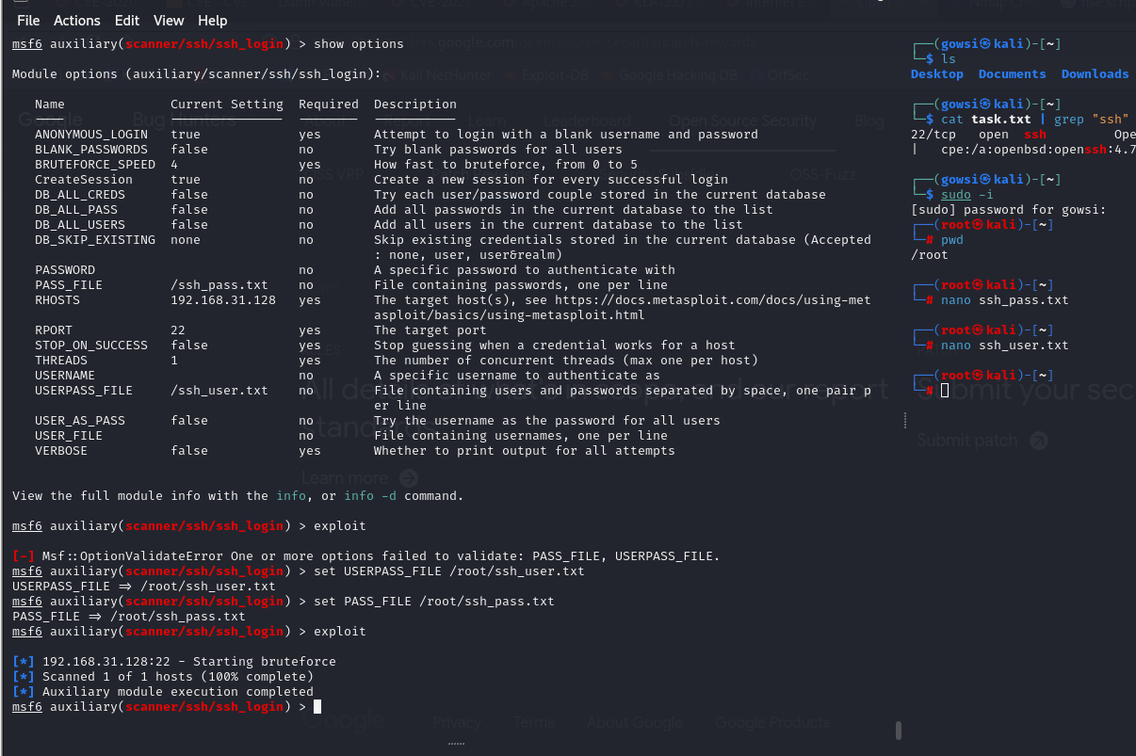

ssh payload configuration

